Biology is the scientific study of life, spanning molecules to ecosystems and integrating structure, function, heredity, and evolution. Modern biology combines experimental, computational, and observational approaches to explain how living systems are organized, how they change over time, and how they interact with one another and their environments. This article surveys core concepts, key methods, and major research directions shaping contemporary biological science.
Defining Life and Biological Organization

Living systems share common properties including cellular organization, metabolism, homeostasis, reproduction, response to stimuli, information storage, and evolutionary adaptation. Biological organization is often described as hierarchical: molecules form organelles and cells; cells form tissues and organs; organisms form populations and communities; these interact within ecosystems and the biosphere. Emergent properties arise at each level, meaning system behavior cannot always be predicted by studying parts in isolation. Research in systems biology and ecology explicitly targets these cross-scale interactions to connect molecular mechanisms to organismal traits and environmental outcomes.
Biology is the scientific study of life, spanning molecules to ecosystems and integrating structure, function, heredity, and evolution. Modern biology combines experimental, computational, and observational approaches to explain how living systems are organized, how they change over time, and how they interact with one another and their environments. This article surveys core concepts, key methods, and major research directions shaping contemporary biological science.
Biology unifies diverse phenomena through core principles: cellular organization, information flow from DNA to phenotype, energy transformation, and evolution within ecological contexts. Rapid advances in imaging, sequencing, and computational analysis are transforming the field from descriptive to increasingly predictive science. The central research task ahead is integration—linking molecular mechanisms to organismal traits and ecosystem outcomes—while ensuring reproducibility, ethical governance, and translation of knowledge to improve health, sustainability, and biodiversity stewardship.
Cell Theory, Cellular Structure, and Bioenergetics
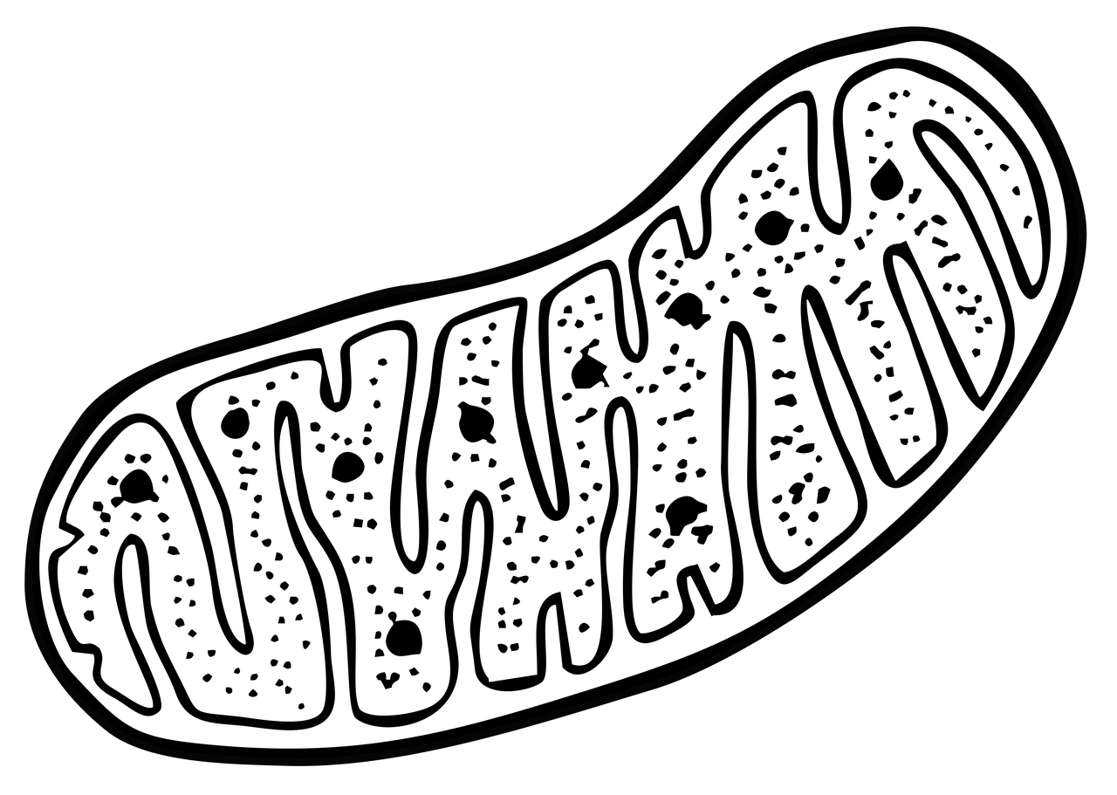
Cell theory holds that cells are the basic unit of life, all organisms are composed of cells, and cells arise from preexisting cells. Prokaryotic cells (bacteria and archaea) lack a membrane-bound nucleus, while eukaryotic cells (animals, plants, fungi, protists) contain organelles such as the nucleus, mitochondria, endoplasmic reticulum, and in plants, chloroplasts. Cellular membranes regulate transport and signaling through lipid bilayers and embedded proteins. Bioenergetics studies how cells capture and convert energy: photosynthesis converts light energy into chemical energy, while cellular respiration extracts energy from organic molecules to produce ATP. Contemporary research emphasizes mitochondrial function, redox balance, and metabolic rewiring in development, immunity, aging, and cancer.
Biology is the scientific study of life, spanning molecules to ecosystems and integrating structure, function, heredity, and evolution. Modern biology combines experimental, computational, and observational approaches to explain how living systems are organized, how they change over time, and how they interact with one another and their environments. This article surveys core concepts, key methods, and major research directions shaping contemporary biological science.
Biology unifies diverse phenomena through core principles: cellular organization, information flow from DNA to phenotype, energy transformation, and evolution within ecological contexts. Rapid advances in imaging, sequencing, and computational analysis are transforming the field from descriptive to increasingly predictive science. The central research task ahead is integration—linking molecular mechanisms to organismal traits and ecosystem outcomes—while ensuring reproducibility, ethical governance, and translation of knowledge to improve health, sustainability, and biodiversity stewardship.
Genetics, Genomes, and Gene Regulation
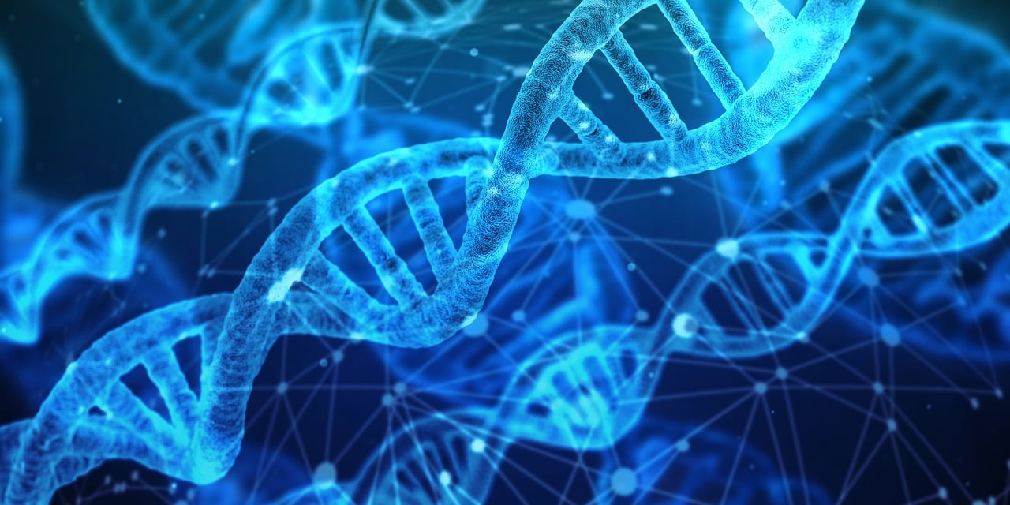
Genetics explains heredity and variation through DNA sequence information and its transmission across generations. Genomes encode genes and regulatory elements; gene expression is controlled at multiple levels including transcription, RNA processing, translation, and protein turnover. Epigenetic mechanisms such as DNA methylation, histone modification, and chromatin remodeling influence gene accessibility without changing DNA sequence, linking environment and development to long-term expression patterns. High-throughput sequencing has enabled genome assembly, population genomics, and functional annotation, revealing that many traits are polygenic and shaped by gene–environment interactions. Current research priorities include interpreting noncoding variants, mapping gene regulatory networks, and understanding how chromatin architecture shapes cell identity.
Biology is the scientific study of life, spanning molecules to ecosystems and integrating structure, function, heredity, and evolution. Modern biology combines experimental, computational, and observational approaches to explain how living systems are organized, how they change over time, and how they interact with one another and their environments. This article surveys core concepts, key methods, and major research directions shaping contemporary biological science.
Biology unifies diverse phenomena through core principles: cellular organization, information flow from DNA to phenotype, energy transformation, and evolution within ecological contexts. Rapid advances in imaging, sequencing, and computational analysis are transforming the field from descriptive to increasingly predictive science. The central research task ahead is integration—linking molecular mechanisms to organismal traits and ecosystem outcomes—while ensuring reproducibility, ethical governance, and translation of knowledge to improve health, sustainability, and biodiversity stewardship.
Evolutionary Biology and the Sources of Biodiversity

Evolution by natural selection explains adaptation as differential survival and reproduction of heritable variants. Additional forces include mutation, genetic drift, gene flow, and recombination. Speciation can occur through geographic isolation, ecological divergence, or hybridization, producing the diversity of life observed today. Phylogenetics reconstructs evolutionary relationships using morphological data and increasingly genomic data, enabling tests of evolutionary hypotheses and timing of divergence events. Evolutionary theory also informs medicine and agriculture, for example by explaining antibiotic resistance, viral evolution, and pesticide resistance. Active areas of research include the genetic basis of adaptation, the role of developmental constraints, and how ecological dynamics shape evolutionary trajectories.
Biology is the scientific study of life, spanning molecules to ecosystems and integrating structure, function, heredity, and evolution. Modern biology combines experimental, computational, and observational approaches to explain how living systems are organized, how they change over time, and how they interact with one another and their environments. This article surveys core concepts, key methods, and major research directions shaping contemporary biological science.
Biology unifies diverse phenomena through core principles: cellular organization, information flow from DNA to phenotype, energy transformation, and evolution within ecological contexts. Rapid advances in imaging, sequencing, and computational analysis are transforming the field from descriptive to increasingly predictive science. The central research task ahead is integration—linking molecular mechanisms to organismal traits and ecosystem outcomes—while ensuring reproducibility, ethical governance, and translation of knowledge to improve health, sustainability, and biodiversity stewardship.
Physiology, Development, and Homeostasis
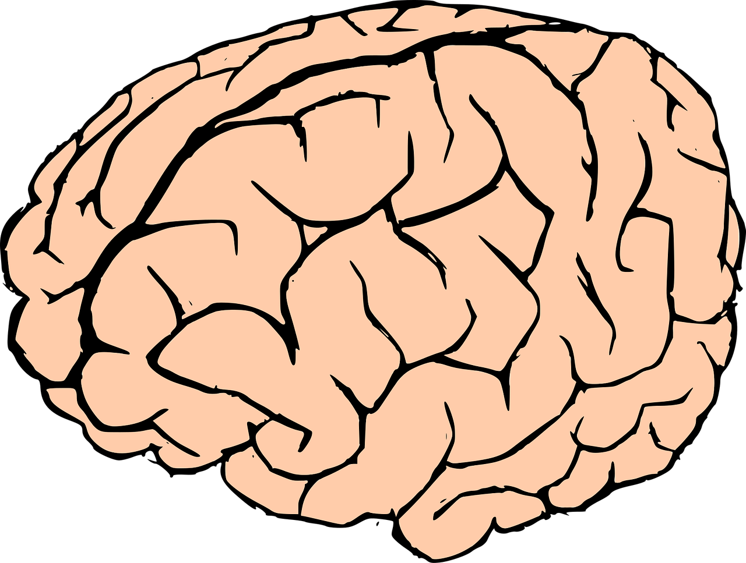
Physiology investigates how organisms function, from cellular signaling to organ systems. Homeostasis maintains internal stability through feedback control, exemplified by thermoregulation, glucose regulation, and osmotic balance. Developmental biology studies how a single cell gives rise to complex multicellular form through gene regulation, cell differentiation, morphogen gradients, and mechanical forces. Hormones and neural circuits coordinate organismal responses to internal and external change. Research frontiers include organoid models of human tissues, single-cell maps of development, and the integration of biomechanics with gene regulation to explain morphogenesis and regeneration.
Biology is the scientific study of life, spanning molecules to ecosystems and integrating structure, function, heredity, and evolution. Modern biology combines experimental, computational, and observational approaches to explain how living systems are organized, how they change over time, and how they interact with one another and their environments. This article surveys core concepts, key methods, and major research directions shaping contemporary biological science.
Biology unifies diverse phenomena through core principles: cellular organization, information flow from DNA to phenotype, energy transformation, and evolution within ecological contexts. Rapid advances in imaging, sequencing, and computational analysis are transforming the field from descriptive to increasingly predictive science. The central research task ahead is integration—linking molecular mechanisms to organismal traits and ecosystem outcomes—while ensuring reproducibility, ethical governance, and translation of knowledge to improve health, sustainability, and biodiversity stewardship.
Ecology, Microbiomes, and Ecosystem Processes

Ecology examines interactions among organisms and their environments, including competition, predation, mutualism, and nutrient cycling. Population ecology quantifies growth, carrying capacity, and demographic structure; community ecology explores species coexistence and food web stability. Microbiome research has revealed that microbial communities influence host digestion, immunity, and behavior, while environmental microbiomes drive global biogeochemical cycles such as carbon and nitrogen transformations. Ecosystem science measures energy flow and material cycling, connecting biodiversity to ecosystem services like pollination and water purification. Current challenges include predicting ecosystem responses to climate change, habitat fragmentation, invasive species, and emerging pathogens.
Biology is the scientific study of life, spanning molecules to ecosystems and integrating structure, function, heredity, and evolution. Modern biology combines experimental, computational, and observational approaches to explain how living systems are organized, how they change over time, and how they interact with one another and their environments. This article surveys core concepts, key methods, and major research directions shaping contemporary biological science.
Biology unifies diverse phenomena through core principles: cellular organization, information flow from DNA to phenotype, energy transformation, and evolution within ecological contexts. Rapid advances in imaging, sequencing, and computational analysis are transforming the field from descriptive to increasingly predictive science. The central research task ahead is integration—linking molecular mechanisms to organismal traits and ecosystem outcomes—while ensuring reproducibility, ethical governance, and translation of knowledge to improve health, sustainability, and biodiversity stewardship.
Methods and Tools in Modern Biological Research
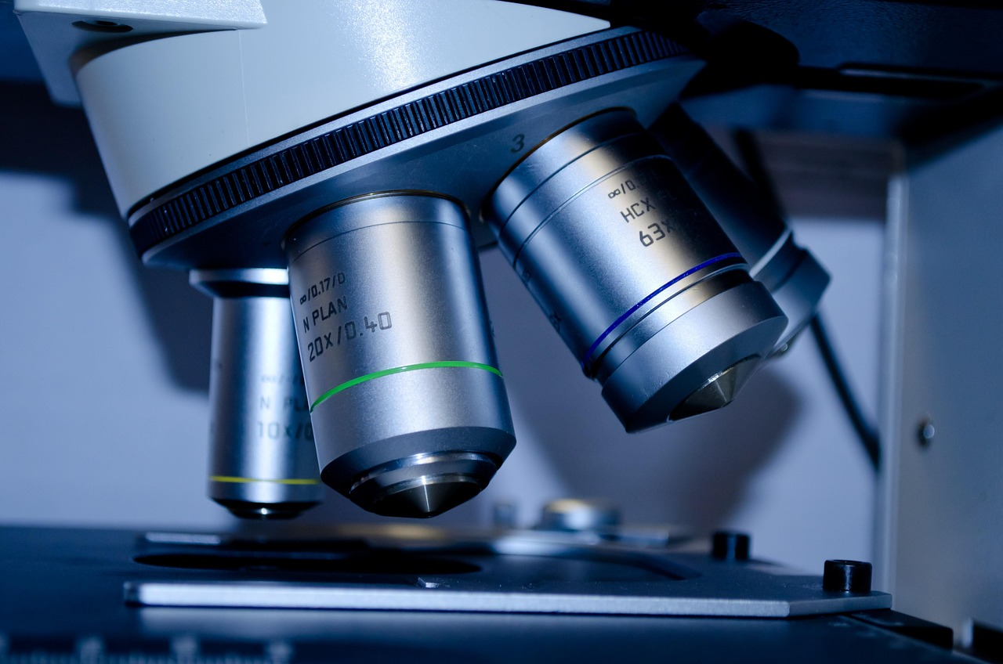
Biological research relies on complementary methods. Microscopy ranges from fluorescence imaging to cryo-electron microscopy for resolving macromolecular structure. Molecular techniques include PCR, cloning, and genome editing (notably CRISPR-based approaches) to test gene function. Omics technologies—genomics, transcriptomics, proteomics, metabolomics—enable system-wide measurement, while single-cell methods resolve cellular heterogeneity. Quantitative biology integrates statistics, mechanistic modeling, and machine learning to infer networks, classify phenotypes, and predict outcomes. Rigorous experimental design emphasizes controls, replication, randomization, and transparent data processing to improve reproducibility across laboratories.
Biology is the scientific study of life, spanning molecules to ecosystems and integrating structure, function, heredity, and evolution. Modern biology combines experimental, computational, and observational approaches to explain how living systems are organized, how they change over time, and how they interact with one another and their environments. This article surveys core concepts, key methods, and major research directions shaping contemporary biological science.
Biology unifies diverse phenomena through core principles: cellular organization, information flow from DNA to phenotype, energy transformation, and evolution within ecological contexts. Rapid advances in imaging, sequencing, and computational analysis are transforming the field from descriptive to increasingly predictive science. The central research task ahead is integration—linking molecular mechanisms to organismal traits and ecosystem outcomes—while ensuring reproducibility, ethical governance, and translation of knowledge to improve health, sustainability, and biodiversity stewardship.
Applications: Medicine, Biotechnology, and Conservation
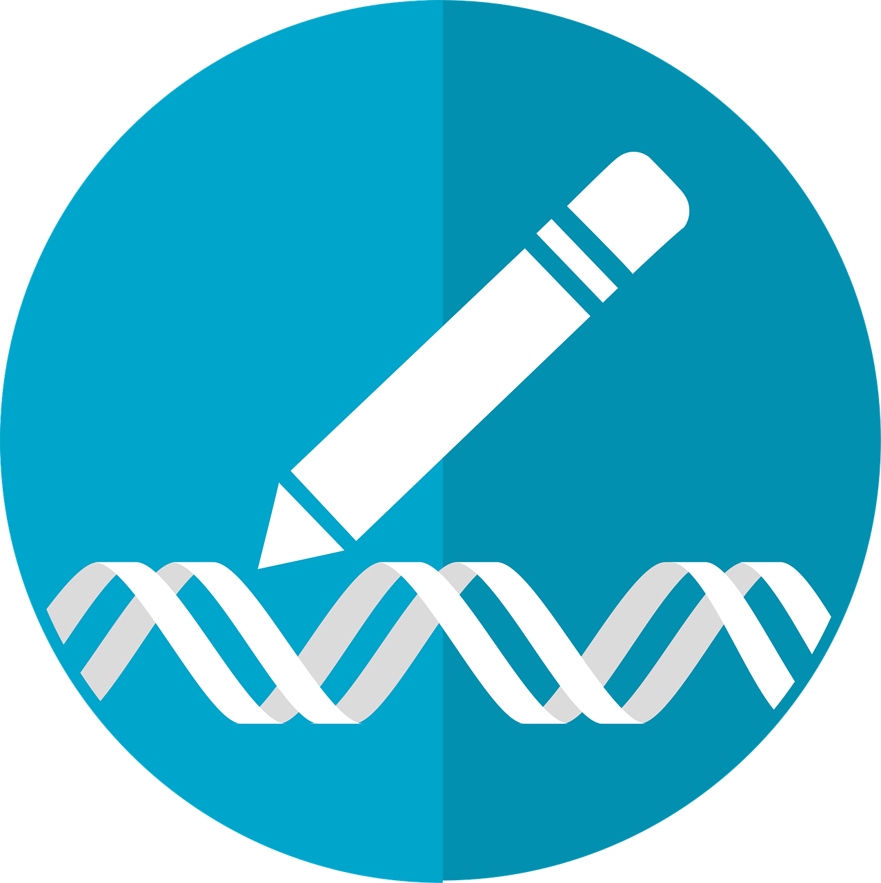
In medicine, biological research underpins vaccine development, cancer therapeutics, regenerative medicine, and precision diagnostics. Understanding pathogen biology informs antimicrobial strategies, while immunology guides treatments for autoimmunity and transplant rejection. Biotechnology applies biological systems to produce pharmaceuticals, enzymes, biofuels, and engineered crops; synthetic biology designs genetic circuits and microbial factories. Conservation biology uses population genetics, habitat modeling, and ecological monitoring to prevent biodiversity loss and sustain ecosystem services. Ethical and societal considerations include biosafety, equitable access to therapies, privacy in genomic data, and responsible deployment of engineered organisms.
Biology is the scientific study of life, spanning molecules to ecosystems and integrating structure, function, heredity, and evolution. Modern biology combines experimental, computational, and observational approaches to explain how living systems are organized, how they change over time, and how they interact with one another and their environments. This article surveys core concepts, key methods, and major research directions shaping contemporary biological science.
Biology unifies diverse phenomena through core principles: cellular organization, information flow from DNA to phenotype, energy transformation, and evolution within ecological contexts. Rapid advances in imaging, sequencing, and computational analysis are transforming the field from descriptive to increasingly predictive science. The central research task ahead is integration—linking molecular mechanisms to organismal traits and ecosystem outcomes—while ensuring reproducibility, ethical governance, and translation of knowledge to improve health, sustainability, and biodiversity stewardship.

